UNIT 1

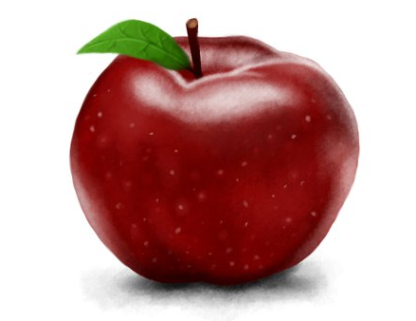

Core lesson 1
- Nouns and Gender
Nouns that name males are generally masculine.  Ex. un hombre (a man), un niño (a boy)  Almost all nouns that end in –o are masculine.  Ex. un huevo (an egg), un carro (a car) | Nouns that name females are generally feminine.  Ex. una mujer (a woman), una niña (a girl)  Almost all nouns that end in –a are feminine.  Ex. una manzana (an apple), una bicicleta (a bicycle)

- Greetings and Farewells

A formal greeting is used when most of the people involved do not know each other well, or
are not on a first-name basis. Formal greetings are also used when meeting someone for the
first time:

Buenos días. (Good morning)
Buenas tardes. (Good afternoon)
Buenas noches. (Good evening or Good night)
¿Cómo está usted? (How are you, Mr/Mrs?)

An informal greeting is used in situations where the people know each other well, such as with
friends or family. It is also used when an adult is speaking to a child. First names are often used in conjunction with an informal greeting:

Hola. (Hello or Hi)
¿Cómo estás? (How are you?)
¿Qué pasa? (what’s up?)

An appropriate response to questions such as:

¿Cómo está usted? (How are you, Mr/Mrs.?) Formal
¿Cómo estás? (How are you?) Informal

is:
Muy bien, gracias. (I’m fine, thanks)

¡Adiós! (Bye) is an appropriate farewell for both formal and informal occasions.

- Forming plurals
How to form the plural form of a Spanish noun depends on its ending. There are several different endings:
-Nouns ending in a vowel get the ending -s.
perro – perros
escuela – escuelas

-Nouns ending in a consonant have the ending -es.
mujer – mujeres
doctor – doctores

-Nouns ending in -z have it changed into c when the plural -es is added.
pez – peces
lápiz – lápices

- Definite and indefinite articles
Articulo definido |  |  | Articulo indefinido
 | Masculino (m) | Femenino (f) |  | Masculino (m) | Femenino (f)
Singular | El (the) | La (the) | Singular | Un (an,a) | Una (an,a)
Plural | Los (the) | Las (the) | Plural | Unos (some) | Unas (some)

- Singular, plural and gendered nouns
Examples:
Masculino |  | Femenino
Singular | Plural | Singular | Plural
El niño | Los niños | La niña | Las niñas
El hombre | Los hombres | La mujer | Las mujeres
Un huevo | Unos huevos | Una casa | Unas casas
Un carro | Unos carros | Una bicicleta | Unas bicicletas

- Third-person pronouns and plurals
Personal pronouns are words used instead of nouns to represent people or things. In this case, we will work with third-person pronoun.
Tercera persona
 | Singular | Plural
Masculino | Él (he) | Ellos (they)
Femenino | Ella (she) | Ellas (they)

Example: El niño bebe agua Él bebe agua
(The boy drinks water) (He drinks water)

La mujer come una manzana Ella come una manzana
(The woman eats an apple) (She eats an apple)

- Subject-verb agreement

A verb is a part of speech that expresses action, existence or mode of being.
In both English and Spanish, a verb, to be used in forming a complete sentence, must be accompanied by a noun or pronoun (known as a subject).

Example:

 | Subject | Verb | Direct object
Singular | La mujer  (the woman) | bebe  (drinks) | café  (coffee)
Plural | Las mujeres  (The women) | beben  (drink) | café  (coffee)

Using third-person pronouns

 | Subject | Verb | Direct object
Singular | Ella  (She) | bebe  (drinks) | café  (coffee)
Plural | Ellas  (They) | beben  (drink) | café  (coffee)

In Spanish, however, the subject can be implied rather than explicitly stated. So in Spanish as sentence as "come" (he or she eats) is complete while "eats" isn't.

Core lesson 2
- Personal pronouns
Pronouns are words that replace nouns. A pronoun must agree in number and gender with the noun that it represents. Note that the personal pronouns on which this Lesson focuses on are subject pronouns:

Él tiene un gato. (He has a cat)
Ella lee un libro. (She reads a book)
Ellos comen manzanas. (They eat apples)
Ellas duermen. (They sleep)

- Dropping Subject Pronouns
Yo duermo. Duermo.
Él duerme. Duerme.
Ella no duerme. No duerme.
Ellos duermen. Duermen.

- Simple present tense structure

Subject | verb | Direct object
La mujer  (The woman) | tiene  (has) | un perro  (a dog)

- Affirmative sentence:
Ex. El niño bebe agua. (The boy drinks water)

Las niñas tienen bicicletas. (The girls have bicycles)

- Negative sentence:
Ex. El niño no bebe agua (The boy doesn’t drink water)

Las niñas no tienen bicicletas. (The girls doesn’t have bicycle)

- Question word ¿Qué?

¿Qué es esto? (What is that?)
Un carro (A car)

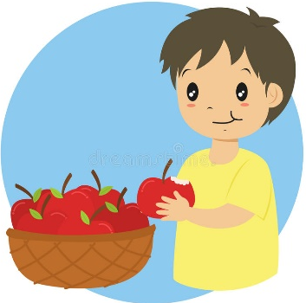
¿Qué come el niño?
El niño come unas manzanas. / Él come unas manzanas

What does the boy eat?
The boy eats some apples. / He eats some apples.

- Yes/ No questions

¿La niña come arroz? ¿El hombre bebe café?
Si, ella come arroz No, él bebe agua

Is the girl eating rice? Is the man drinking coffee?
Yes, she is eating rice No, He isn’t. He is drinking water.
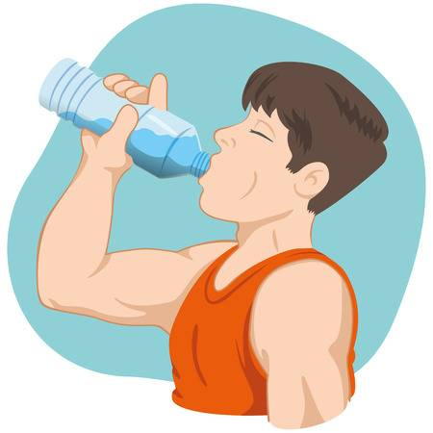

¿Usted es doctor? ¿Ella es enfermera?
Si. No.

Are you a doctor? Is she a nurse?
Yes. No.

Core lesson 3

- The verb TO BE (verbo SER)
Pronombre | Verbo SER | Pronoun | Verb TO BE
Yo | soy | I | am
Tú | eres | You | are
Él/ Ella | es | He /She | is
Usted |  | You | are
Ellos (as) | son | They | are
Nosotros (as) | somos | We | are

a. Descriptions
Name  Yo soy Raúl. I am Raul. | Physical descriptions  La manzana es verde. The apple is green.
Nationalities  Bob es americano. Bob is American. | Qualities  Las flores son pequeñas. The flowers are small.

b. Occupations
Soy profesora de español. I am a Spanish teacher. | Ellos son estudiantes. They are students.
Mi padre es doctor. My father is a doctor. | Emma es bailarina. Emma is a dancer.

c. Characteristics are personality descriptions of a person.
Mary es inteligente y amable. Mary is intelligent and friendly.

d. Time can refer to days, dates, years, and the time on the clock.
Hoy es miércoles. Today is Wednesday. | Son las cinco veinticinco. It's five twenty-five.

e. Origin
Rosa es de España. Rosa is from Spain. | Este chocolate es de México. This chocolate is from Mexico.
Las sillas son de madera.  The chairs are made of wood. | Mi anillo es de oro.  My ring is made of gold.

f. Relationships
Sarah es mi madre.  Sarah is my mother. | John es mi jefe.  John is my boss.
Marcos es tu enamorado.  Marcos is your boyfriend. | Peter y Susan son mis padres.  Peter and Susan are my parents.

Core lesson 4
- Noun-Adjective Agreement

An adjective must agree with the noun it is modifying in both number and gender:

Example:

La taza es blanca. The cup is white.
El carro es blanco. The car is white.
Los libros son rojos. The books are red.
Las bicicletas son rojas. The bicycles are red.

- Questions and Answers

Note the order of subject and verb placement in questions and their corresponding answers:

¿Qué está haciendo el médico? What is the doctor doing?
El médico está escribiendo. The doctor is writing

¿Cuántas llaves hay? How many keys are there?
Hay cuatro llaves. There are four keys.

The interrogative terms are written with accent marks:

¿Quién tiene los libros? Who has the books?
¿Cuántos árboles hay? How many trees are there?
¿Qué está haciendo la mujer? What is the woman doing?

- There is /there are Hay

Hay un niño There is a boy
Hay cuatro perros There are four dogs
Hay un maestro There is a teacher
Hay dos peces rojos There are two red fish

Vocabulary Taught or Reviewed

Spanish | English | Spanish | English
niño | boy | beber | to drink
niña | girl | llevar | to wear
mujer | woman | comprar | to buy
hombre | man | dormir | to sleep
perro | dog | manejar | to drive
gato | cat | grande | big
caballo | horse | zapatos | shoes
pez | fish | taza | cup
agua | water | tazón | bowl
café | coffee | plato | dish
leche | milk | flor | flower
pan | bread | teléfono | phone
arroz | rice | mesa | table
sándwich | sandwich | silla | chair
huevo | egg | llave | keys
manzana | apple | alumno | student
carro | car | profesor | teacher
periódico | newspaper | médico | doctor
bicicleta | bicycle | policía | policeman
libro | book | adulto | adult
bolígrafo | pen | cielo | sky
camisa | shirt | pasto | grass
blusa | blouse | sol | sun
pantalones | pants | luna | moon
abrigo | coat | y | and
vestido | dress | con | with
falda | skirt | tamaño | size
camiseta | t-shirt | pequeño | small
comer | to eat | tener | to have
correr | to run | si | yes
cocinar | to cook | no | not
escribir | to write | qué | what
nadar | to swim | caminar | to walk
leer | to read

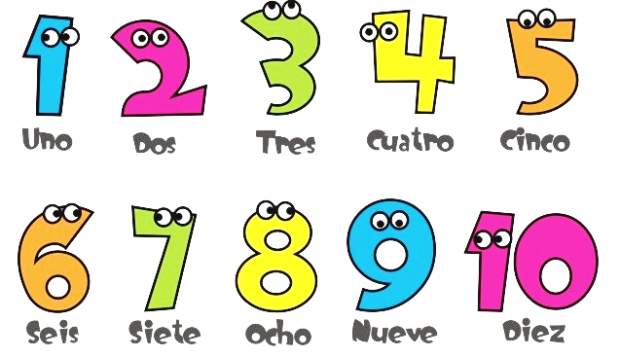
NÚMEROS (NUMBERS)

COLORES (COLORS)
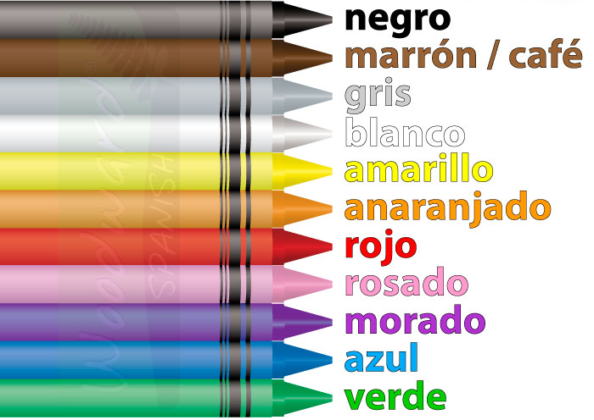

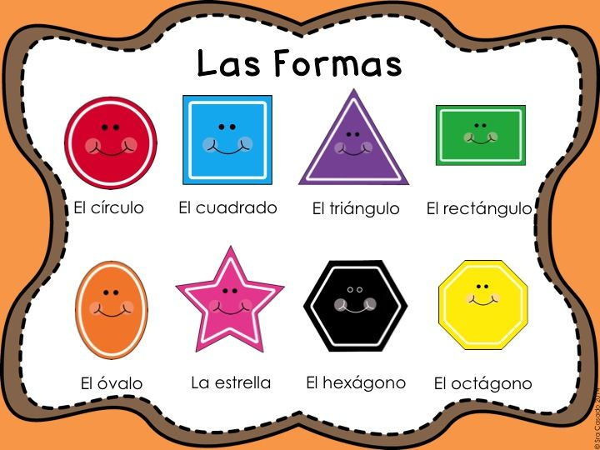
Shapes

UNIT 2

Core lesson 1
- Compound Subjects
A sentence with more than one subject is said to contain a compound subject. The conjunction y joins the subjects together:
El niño y su perro juegan. The boy and his dog are playing.
La madre y sus hijas juegan. The mother and her daughters are playing
Since a compound subject is plural, its corresponding verb must match it in number:
El niño y su perro juegan. The boy and his dog are playing.
La madre y sus hijas juegan. The mother and her daughters are playing.

- Possessive adjectives must agree with the noun they modify in terms of gender and number.
Examples:
Mi bicicleta es roja. My bicycle is red.
What is the subject? | bicicleta
What is the possessive adjective? | mi
What is the descriptive adjective? | roja

Both the possessive and descriptive adjectives will reflect the gender and quantity of the subject noun, “bicicleta.”
A chart for possessive adjectives in Spanish
Singular |  | Plural |  | Translation
Masculine | Feminine | Masculine | Feminine
mi |  | mis |  | my
tu |  | tus |  | your (familiar)
su |  | sus |  | his, her, its, their, your (formal)
nuestro | nuestra | nuestros | nuestras | our

Examples:
Tu hermano es un doctor. Your brother is a doctor
Mis pantalones son azules. My pants are blue
Nuestra casa es grande. Our house is big
- Demonstratives

A demonstrative adjective always accompanies a noun. In the phrase: Este carro, the demonstrative adjective "este" explains which car you are talking about (this car).

Close to the speaker
 | singular | plural
Masculine | este (this) | estos (these)
Feminine | esta (this) | estas (these)
Away from the speaker ---
 | singular | plural
Masculine | ese (that) | esos (those)
Feminine | esa (that) | esas (those)
Far from the speaker --------------------
 | singular | plural
Masculine | aquel (that over there) | aquellos (those over there)
Feminine | aquella (that over there) | aquellas (those over there)

Notice that demonstrative adjectives are also determined by number and gender.
Examples:
Prefiero este pantalon - I prefer this sweater.(masculine, singular)
Prefiero estos pantalones - I prefer these sweaters.(masculine, plural)

Prefiero esta blusa - I prefer this blouse.(feminine, singular)
Prefiero estas blusas - I prefer these blouses.(feminine, plural)

- Questions words

How many? ¿Cuántos?

Question to ask quantity.

Examples:
¿Cuántas manzanas hay?  Hay cuatro manzanas. | How many apples are there?  There are four apples.
¿Cuántos niños hay?  Hay diez niños. | How many children are there?  There are ten children.

How old are you? ¿Cuántos años tienes?

Question to know people’s age.

Examples:

¿Cuántos años tienes?  Yo tengo cinco años. | How old are you?  I am five years old.
¿Cuántos años tiene él/Jason?  El/ Jason tiene ….años. | How old is he/Jason?  He/ Jason is …. years old.
¿Cuántos años tiene ella/Emma?  Ella/ Emma tiene …. años. | How old is she/ Emma?  She/ Emma is …. years old.

Core lesson 2
- Direct objects

A direct object is the direct recipient of the action of a verb. It represents who or what receives the action:

Examples:

Los padres están mirando a sus hijas. The parents are watching their daugthers.
Yo compro una falda. I buy a skirt.
Ellos están leyendo sus libros. They are Reading their books.

- Interrogative terms

The following interrogative terms request specific information for answers:

Term  ¿Quién?  ¿Quién está comiendo?  El policía está comiendo | Who?  Who is eating?  The policeman is eating | Request  Identify a person
Term  ¿Qué?  ¿Qué estás haciendo?  Estoy escribiendo  ¿Qué es esto?  Esto es un árbol  ¿Qué tiene el niño?  El niño tiene un perro | What  What are you doing?  I am eating.  What is that?  That is a tree.  What does the boy have?  The boy has a dog. | Request  Identity of an action or object
Term  ¿Cuántos/-as?  ¿Cuántos años tienes?  Tengo diez años. | How many?  How old are you?  I am ten years old | Request  Quantity
Term  ¿Dónde?  ¿Dónde están las tazas?  Las tazas están en el fregadero. | Where?  Where are the cups?  The cups are in the sink. | Request  Location

- Prepositions of place
en | in
sobre | on
debajo | under

Examples:
El conejo está en el sombrero
The rabbit is in the hat.

El libro está sobre la mesa
The book is on the table.

El niño está debajo de la mesa
The boy is under the table.

Core lesson 3

- Syllables and Stress
The stressed and unstressed syllables are important components of correct. There are rules to determine which syllable to stress:
When a word ends in a vowel or the letter n or s, the stress falls on the next-to-last syllable:
Parque habla
When a word ends in any consonant other than n or s, the stress falls on the last syllable:
Estar ciudad
When a word contains an accent mark, the stress falls on the syllable with the accent:
Tazón país

- Personal pronouns
PRONOMBRES PERSONALES
SUBJECT PRONOUNS
 |  | SINGULAR | PLURAL
1ST person |  | I  YO | WE  NOSOTROS  NOSOTRAS
2nd person | INFORMAL | YOU  TÚ | YOU  VOSOTROS  VOSOTRAS  SPAIN
2nd person | FORMAL | YOU  USTED | YOU  USTEDES  LATIN AMERICA
3rd person |  | HE/SHE  ÉL /  ELLA | THEY  ELLOS  ELLAS

Yo
To say “I” in Spanish, say yo. Yo is not capitalized unless it starts a sentence:
Yo hablo español. Afortunadamente yo hablo español.
I speak Spanish. Fortunately I speak Spanish.
In many regions the y in yo is pronounced very strongly and sounds more like “jo.”

Tú
To say “you” in Spanish, say tú. Tú can only be singular; you cannot use tú to address a group of people. Also, the accent on the "u" is not optional; tu (without the accent) means “your” not “you.” (The words tú and tu are pronounced the same way.)
Tú hablas español.
You speak Spanish.
Él, Ella
To say "he" in Spanish, say él. Like tú, the accent on the "e" is not optional; el (without the accent) means “the” not "he." (The words él and el are pronounced the same way.)
To say "she" in Spanish, say ella. Remember that the double-l is pronounced like a y.
Él habla español. Ella habla español.
He speaks Spanish. She speaks Spanish.
Nosotros, Nosotras
Note: If you are male, it’s very unlikely you would ever have reason to say or write nosotras.
Usually when you need to say “we” in Spanish, you say nosotros. The exception is when a female is referring to herself and other females. She will say nosotras. What about a mixed group? It’s not very nice or politically correct but only groups consisting entirely of females are considered feminine (nosotras). Add one male to the group and whole group is considered masculine (nosotros).
Nosotros hablamos español.  We (group with one or more males) speak Spanish. | Nosotras hablamos español.  We (all female group) speak Spanish.

Ellos, Ellas
Ellos hablan español.  They (group with one or more males) speak Spanish. | Ellas hablan español.  They (all female group) speak Spanish.
To say “they” in Spanish, you say either ellos or ellas. Which is which? The same gender rules you learned in nosotros apply. A group consisting entirely of females should be referred to as ellas. Any group with at least one male in it should be referred to as ellos. If you're ever in doubt, it's best to use the masculine form.

Tú vs. Usted
Generally speaking you should use tú when you are addressing someone with whom you have an informal relationship like a friend, a colleague, or a close family member. Use usted when addressing someone with whom you have a more respectful relationship like an elder, a boss, or a dignitary. For example:
speaking to a child: | speaking to a professor:
Tú escribes bien.  You write well. | Usted escribe bien.  You write well.

What About “It”?
“It” is a subject pronoun in English used to refer to something that doesn't have a gender or whose gender isn't known. There is no equivalent subject pronoun in Spanish. So how do you say “it” in Spanish? You don’t. You simply omit the subject pronoun altogether: Es bonita. It is beautiful.

- Around the world - questions

Examples:

¿De dónde eres? (informal)  Soy de Canadá  ¿De dónde es usted? (formal)  Soy de Colombia | Where are you from?  I am from Canada  Where are you from?  I am from Colombia
¿Dónde vives?  Vivo en Elizabethtown. | Where do you live?  I live in Elizabethtown.
¿Cómo se llama tu país?  Mi país se llama Perú | What is the name of your country?  The name of my country is Peru
¿Está Japón lejos de España?  No | Is Japan far from Spain?  No
¿Está Italia cerca de Francia?  Si | Is Italy near from France?  Yes

- Greetings and Introductions

Hola. | Hello. / Hi.
Buenos días. | Good morning.
Buenas tardes. | Good afternoon.
Buenas noches. | Good evening /Goodnight.
Adiós/ Chao | Bye. / Goodbye.
Hasta luego | See you later
Hasta pronto | See you soon
Hasta mañana. | See you tomorrow.
¿Cómo estás? / ¿Qué tal? | How are you?
Bien. / Muy bien. | Fine.
Encantado/a de conocerte | Nice to meet you
¿qué hay? | What's up? / what's new?

Conversation
Speaker 1: Hola. Me llamo ……. ¿Cómo te llamas? Hi. My name is ……… What’s your name?
Speaker 2: Me llamo …………... My name is ……………..
Speaker 1: Encantado/a de conocerte. Nice to meet you
Speaker 2: Encantado/a de conocerte. Nice to meet you, too.
Speaker 1: Adiós. Bye
Speaker 2: Adiós. Bye
- Countries and cities – Paises y ciudades

Pais | Ciudad | Country | City
Estados Unidos | Nueva York | United States | New York
Italia | Roma | Italy | Rome
Egipto | El Cairo | Egypt | =
Francia | Paris | France | =
China | Beijing | China | =
Rusia | Moscú | Russia | Moscow
Brasil | Rio de Janeiro | Brazil | =
Mexico | Mexico D.F | Mexico | Mexico city
España | Madrid | Spain | Madrid

- Spanish Speaking Countries

Argentina | =
Bolivia | =
Chile | =
Colombia | =
Costa Rica | =
Cuba | =
Ecuador | =
El Salvador | =
España | Spain
Guatemala | =
Guinea Ecuatorial | Equatorial Guinea
Honduras | =
México | Mexico
Nicaragua | =
Panamá | Panama
Paraguay | =
Perú | Peru
República Dominicana | Dominican Republic
Uruguay | =
* Puerto Rico is currently a commonwealth of the United States.

Core lesson 4
- Asking and Answering Questions
¿De qué color es…………..?  (sustantivo) | What color is ……..?  (noun)
¿De qué color es su suéter?  Su suéter es azul. | What color is her sweater?  Her sweater is blue
¿De qué color es tu pelo?  Soy pelirroja. | What color is your hair?  I am red hair.

To ask about personal physical states.
¿Cómo está usted?  Estoy enferma. | How are you?  I’m sick
¿Cómo estás?  Estoy cansada. | How are you?  I’m tired
¿Cómo está usted?  Muy bien, gracias. | How are you?  I’m fine, thanks.

- Descriptive Adjectives

Adjectives modify nouns. An adjective describes a person, place, thing, or idea in a
way that sharpens images and helps people communicate more precisely. Note that
the most basic way to use an adjective is to place it after the noun it describes.

El hombre alto lleva un traje negro. The tall man wears a black suit
La mujer baja lleva un traje gris. The short woman wears a gray suit

Remember that adjectives must agree with the noun they modify in terms of
gender and number.

una camisa roja (femenino, singular) | Unos caballos negros (masculino, plural)
A red shirt | Some black horses

- How Are They Feeling?

To express physical states
Los hombres y las mujeres tienen frío y los niños y las niñas tienen calor.
La madre está bien y el hijo está enfermo.
To ask questions about the physical states
¿Quién tiene hambre?  La mujer alta tiene hambre. | Who is hungry?  The tall woman is hungry
¿Quién está bien?  El bebé está bien. | Who is ok?  The baby is ok.
¿Quién tiene sed?  El perro negro tiene sed. | Who is thirsty?  The black dog is thirsty.
¿Quién está cansado?  El abuelo está cansado. | Who is tired?  The grandfather is tired.

- Speaking conversations

Speaker 1: Hola.  Speaker 2: Hola.  Speaker 1: ¿Cómo te llamas?  Speaker 2: Me llamo ____. ¿Cómo te llamas tú?  Speaker 1: Me llamo ____. Encantado/a de conocerte.  Speaker 2: Encantado/a de conocerte.  Speaker 1: ¿Cómo estás?  Speaker 2: Estoy bien. ¿Cómo estás tú?  Speaker 1: Estoy bien. ¿De dónde eres?  Speaker 2: Soy de ____. ¿De dónde eres tú?  Speaker 1: Soy de____. ¿Dónde vives?  Speaker 2: Vivo en ____. ¿Dónde vives tú?  Speaker 1: Vivo en ____. Adiós.  Speaker 2: Adiós. | Speaker 1: Hello  Speaker 2: Hello  Speaker 1: What is your name?  Speaker 2: My name is ____. What is your name?  Speaker 1: My name is ____. Nice to meet you.  Speaker 2: Nice to meet you, too.  Speaker 1: How are you?  Speaker 2: I’m fine. How are you?  Speaker 1: I’m fine. Where are you from?  Speaker 2: I’m from ____. Where are you from?  Speaker 1: I’m from ____. Where do you live?  Speaker 2: I live in ____ Where do you live?  Speaker 1: I live in ____. Bye.  Speaker 2: Bye.

Vocabulary Taught or Reviewed
Spanish | English | Spanish | English
Familia | Family | cepillo | toothbrush
madre | mother | jabón | soap
padre | father | toalla | towel
padres | parents | almohada | pillow
abuela | grandmother | sábana | bed sheet
abuelo | grandfather | frazada | blanket
hijo | son | Partes del cuerpo | Body parts
hija | daughter | cabeza | head
hermano | brother | cara | face
hermana | sister | ojos | eyes
nieto | grandson | nariz | nose
nieta | granddaughter | dientes | teeth
primo (a) | cousin | labios | lips
tía | aunt | orejas | ears
tío | uncle | cuello | neck
sobrina | niece | mano | hand
sobrino | nephew | dedos | fingers
esposa | wife | pie | foot
marido, esposo | husband | dedos del pie | toes
gemelos | twins | lugares | places
amigo/a | friend | ciudad | city
bebé | baby | calle | street
house | casa | parque | park
apartamento | apartment | restaurante | restaurant
baño | bathroom | Escuela/colegio | school
cocina | kitchen | hospital | hospital
comedor | Dining room | jugar | To play
sala de estar | living room | ventana | window
dormitorio | bedroom | abrazar | To hug
fregadero | sink | besar | To kiss
Inodoro | toilet | querer (e>ie) | To want
computadora | computer | dónde | where
laptop | laptop | escuchar | To listen
puerta | door | mirar | To look
radio | stereo | parado/-a | stand
televisor | tv | sentado/-a | seated
silla | chair | Llamarse | To be called
ventana | window | vivir | To live
dia | day | lejos | far
semana | week | cerca | near
mes | month | Prendas de vestir | clothig
año | year | aged | edades
hoy | today

UNIT 3

Work and School

Core lesson 1
- Coordinating Conjunctions

Coordinating conjunctions join two independent clauses with actions of equal importance. The coordinating conjunctions that are used in this lesson are y and pero:

La niña tiene un libro y lo está leyendo. The girl has a book and she is reading it.
Yo llevo traje, pero no llevo corbata. I wear a suit, but I don’t wear tie.
Él tiene un huevo y lo está comiendo. He has an egg and he is eating it
Tengo un abrigo, pero no tengo un sombrero. I have a coat, but I don’t have a hat.

- Simple Present Tense

The simple present tense uses one word to indicate an action that is happening right now:

Trabajo en una escuela. I work at school.
¿Tienes hermanas y hermanos? Do you have sisters and brothers?
Él lleva calcetines y zapatos. He wears socks and shoes.
La mujer bebe café. The woman drinks coffee.
Los niños nadan. The children swim.
Ellos leen un periódico. They read a newspaper.

Note that regular verbs are formed from the infinitive in the following way:

Pronouns | -ar verbs | -er verbs | -ir verbs
Yo  Tu  Él/ella/usted  Nosotros/as  Ellos/ellas/ustedes | Replace ar with o  Replace ar with as  Replace ar with a  Replace ar with amos  Replace ar with an | replace er with o  replace er with es  replace er with e  replace er with emos  replace er with en | replace ir with o  replace ir with es  replace ir with e  replace ir with imos  replace ir with en

- Different times of day
For example:
desayunando por la mañana Having breakfast in the morning
almorzando al mediodía having lunch at midday
leyendo por la tarde Reading in the afternoon
durmiendo por la noche sleeping at night
nadando por la tarde swimming in the afternoon

- When, but, before and after
Finishing Sentences
For example:
Él lleva pantalones, pero no lleva correa. He wears pants but he doesn’t wear a belt.
Ella tiene un bolígrafo y está escribiendo. She has a pen and she is writing
La niña tiene un libro, pero no lo está leyendo. The girl has a book but she isn’t reading it.
La mujer bebe leche y come pan. The woman drinks milk and she eats bread.
Creating Sentences
For example:
¿Cuándo trabaja usted? Trabajo por la tarde. What time do you work?
Desayuno antes de trabajar. I have breakfast before working
Bebo leche después de cenar. I drink milk after dinner

Core lesson 2

- Subject-Verb Agreement

The verb in a sentence must match its subject in number and person:

La mujer prueba el arroz. The woman tastes the rice.
El niño está visitando a su abuela. The boy is visiting his grandmother.
Las flores huelen bien. The flowers smell good.
Nuestros invitados están en la puerta. Our guests stand at the door

- The Verb ESTAR

Estar is used to indicate temporary states and locations.
Pronombre | Verbo ESTAR | Pronoun | Verb TO BE
Yo | estoy | I | am
Tú (informal) | estás | You | are
Él/ Ella | está | He /She | is
Usted (formal) |  | You | are
Ellos (as) | están | They | are
Nosotros (as) | estamos | We | are

a. Position refers to the physical position or posture a person or thing is in.
Mi abuela está sentada. My grandmother is seated.

b. Location
The location of someone or something describes where it is permanently, temporarily, or conceptually.
El baño está a la derecha de la sala. The bathroom is to the right of the living room.
Estamos en el colegio ahora We are at the school right now

c. Actions
Estoy lavando los platos sucios. I am washing the dirty dishes.
Estamos leyendo los periódicos. We are reading the newspapers.

d. Conditions
Physical and mental conditions are described using estar. Things that are likely to vary over several hours, days, or even years can be fall into this category.
Estoy tan cansada esta mañana. I am so tired this morning.
Mis niños están enfermos hoy. My children are sick today.
Mi padre está un poco loco. My father is a little crazy.
e. Emotions
Estoy triste. I am sad.
Ella está contenta She is happy.
- Calendar Terms
Spanish | English
Un día | day
Una semana | week
Un mes | Month
Un año | Year
hoy | today
Los días de la semana | The days of the week
lunes | monday
martes | tuesday
miércoles | wednesday
jueves | thursday
viernes | friday
Sábado | saturday
domingo | sunday
Tiempos del dia | Times of day
mañana | morning
mediodía | midday
tarde | afternoon
noche | evening
Las estaciones | The seasons
primavera | Spring
verano | summer
otoño | fall
invierno | winter

- Polite expressions in a conversation
It is polite to greet others with one of the following phrases:
Buenos días – Good morning
Buenas tardes – Good afternoon
Buenas noches – Good evening/night

When asking for something, or giving someone something, use these phrases:
Por favor – Please
Gracias – Thanks
De nada – You’re welcome.
No hay de qué – You’re welcome.

When you leave the table, before moving away from a group, or if you are stepping in front of someone, say:
Con permiso – Excuse me.

When someone sneezes, say:
Salud – The literal meaning of salud is “health.” This is used more extensively in Spanish-speaking countries than the English equivalent “bless you.”
When you sneeze and someone says salud, you should respond gracias.

When you bump into someone, if you want to attract someone’s attention or if you interrupt someone, say:
Perdón Excuse me.
Disculpa Excuse me.

- Senses and Seasons

-Oler To smell
-Probar To taste

Hueles las flores. You smell the flowers
La leche huele mal. The milk smells bad
Pruebas un sándwich. You taste a sandwich
El pan está rico. The bread is delicious
La flor huele bien. The flower smells good
El café está feo. The coffee is awful
Sign of seasons
Hueles flores en la primavera You smell flowers in spring
Juegas afuera en el verano You play outside in summer
Pruebas manzanas en el otoño You taste apples in fall
Estás adentro de la casa en el invierno You are at home in winter

Conversations
Dialogues can include the following:
a time-of-day greeting a sentence with bienvenido/a welcome
an opener (¿Cómo estás?) a question with dónde/ where
a home country a question with cuándo/ when
a name a farewell
a day of the week
Sample dialogue:
Student 1: Buenos días.
Student 2: Buenos días.
Student 1: ¿Cómo estás?
Student 2: Estoy bien.
Student 1: Me llamo Adam Carter. ¿Cómo te llamas?
Student 2: Me llamo Nadia Tamir.
Student 1: ¿De dónde eres?
Student 2: Soy de Egipto, pero estoy visitando Nueva York.
Student 1: ¡Bienvenida a los Estados Unidos!
Student 2: Gracias. ¿Dónde trabajas?
Student 1: Trabajo en un restaurante.
Student 2: ¿Cuándo trabajas?
Student 1: Trabajo los lunes, miércoles y viernes.
Student 2: Adiós.
Student 1: Adiós.

Core lesson 3
Polite Phrases

Use of polite phrases such as the following:

muchas gracias/ thanks: show of gratitude
por favor/ please: polite request
de nada/ you’re welcome: acceptance of gratitude
perdón/ excuse me: to show or ask for allowance

Titles of Address

Use these words when addressing others:

Señor/ Mr: married or unmarried man
Señora/ Mrs: married woman
Señorita/ Miss: unmarried woman

Languages
SP | EN | SP | EN
Español | Spanish | Árabe | Arabic
Inglés | English | Japonés | Japanese
Ruso | Russian | Portugués | Portuguese
Chino | Chinese | Francés | French
Italiano | Italian | Alemán | German

For example:
Yo hablo español I speak Spanish
No hablo ruso I dont speak Russian
Los niños hablan inglés The children speak English
Las personas de Colombia hablan español. People from Colombia speak Spanish
Las personas de Egipto hablan árabe. People from Egypt speak Arabic.

Numbers to 69
10 | diez | 22 | veintidós | 40 | cuarenta
11 | once | 23 | veintitrés | 50 | cincuentas
12 | doce | 24 | veinticuatro | 60 | sesenta
13 | trece | 25 | veinticinco | 61 | Sesenta y uno
14 | catorce | 26 | veintiséis | 62 | Sesenta y dos
15 | quince | 27 | veintisiete | 63 | Sesenta y tres
16 | dieciséis | 28 | veintiocho | 64 | Sesenta y cuatro
17 | diecisiete | 29 | veintinueve | 65 | Sesenta y cinco
18 | dieciocho | 30 | treinta | 66 | Sesenta y seis
19 | diecinueve | 31 | Treinta y uno | 67 | Sesenta y siete
20 | veinte | 32 | Treinta y dos | 68 | Sesenta y ocho
21 | veintiuno | 33 | Treinta y tres | 69 | Sesenta y nueve

Three-Way Conversation–Student, Teacher, and Parent
Student: Hola, señor Haddad. ¿Cómo está?  Teacher: Estoy bien.  Student: Esta es mi madre, la señora García.  Teacher: Hola.  Parent: Hola. ¿Qué enseña usted?  Teacher: Enseño español.  Parent: Yo hablo español, pero estudio ruso y árabe.  Teacher: Adiós.  Student and Parent: Adiós. | Hi, Mr. Haddad. How are you?  Im fine  This is my mother, Mrs.Garcia  Hi  Hi, What do you teach?  I teach Spanish  I speak Spanish, but I study Russian and Arabic  Bye  Bye

Core lesson 4
- Reflexive Verbs

Reflexive verbs indicate that a person is doing something to or for himself. A reflexive verb consists of a reflexive pronoun and a verb:

Yo me cepillo los dientes después de desayunar.
Tú te llamas Pedro.
Ellos se lavan las manos con jabón.

- Days of the Week

Review

Lunes Monday
Martes Tuesday
miércoles Wednesday
jueves Thursday
viernes Friday
sábado Saturday
domingo Sunday

In Latin American culture, Monday (lunes) is the first day of the week. The terms
sábado and domingo are considered the weekend (el fin de semana).

Waking Up and Washing Up
-Clean, Dirty, Wet, or Dry?
For example:

La camisa está limpia.
Él tiene la cara sucia.
Ella tiene el pelo mojado.
Los caballos están mojados.
El gato está seco.
The shirt is clean
He has a dirty face
She has a wet hair
The horses are wet
The cat is dirty

-What’s the Reason?

The reasons for actions in terms are por qué and porque.

¿Por qué está comiendo dos sándwiches?
Estoy comiendo dos sándwiches porque tengo hambre.

Daily Routines

Me lavo la cara
me despierto
me cepillo el pelo
duermo sobre mi almohada
I wash my face
I wake up
I brush my hair
I sleep on my pillow

You can add adverbs of time.

Me lavo la cara por la mañana y por la noche.
Me cepillo el pelo por la mañana, al mediodía, por la tarde y por la noche.
Me despierto por la mañana.
I was my face in the morning and at night
I brush my hair in the morning, at midday, in the afternoon and at night.

I wake up in the morning

Duermo sobre la almohada por la noche. I sleep on my pillow at night

Household Happenings

Las almohadas y las frazadas The pillows and the blankets are in the
están en el dormitorio. bedroom.
Ella cepilla el caballo afuera. She brushes the horse outside.
El jabón está en el baño. The soap is in the bathroom.
Ellos lavan los platos en la cocina They wash the dishes in the kitchen
porque los platos están sucios. because the dishes are dirty.

Grooming habits

You can change the direct object.

Examples:

Me estoy lavando ____. I am washing
- la cara - my face
- las manos - my hands
- pelo - my hair

Me estoy cepillando los dientes. I am brushing my teeth.

What Is the Question?

Por qué questions. For example:

a.¿Por qué compras flores? Why do you buy flowers?
b.¿Por qué está tu hermana en la cocina? Why is your sister in the kitchen?
c.¿Por qué huelen bien las sábanas? Why do the blankets smell good?
d.¿Por qué está tu familia en la sala de estar? Why is your family in the living room?

Porque statements. For example:

a. porque estoy visitando a mi abuela esta tarde. Because I’ll visit my grandma
b. porque está cocinando. Because she is cooking.
c. porque las sábanas están limpias. Because the blankets are clean.
d. porque está mirando televisión. Because they are watching tv.

Speaking of Conversations

José: Buenas tardes. Me llamo José González. ¿Cómo se llama usted?
Lena: Me llamo Lena Petrov. Encantada de conocerlo.
José: Encantado de conocerla. ¿Cómo está?
Lena: Bien.
José: ¿De dónde es usted?
Lena: Soy de Moscú, pero estoy visitando Bogotá.
José: ¡Bienvenida a Colombia!
Lena: Gracias. ¿Qué está comprando?
José: Estoy comprando flores.
Lena: ¿Por qué está comprando flores?
José: Estoy comprando flores porque voy a visitar a mi hermana esta tarde.
Lena: ¿Dónde vive su hermana?
José: Vive cerca del parque.
Lena: Adiós.
José: Adiós.

José: Buenas tardes. Me llamo José González. ¿Cómo se llama usted?
Lena: Me llamo Lena Petrov. Encantada de conocerlo.
José: Encantado de conocerla. ¿Cómo está?
Lena: Bien.
José: ¿De dónde es usted?
Lena: Soy de Moscú, pero estoy visitando Bogotá.
José: ¡Bienvenida a Colombia!
Lena: Gracias. ¿Qué está comprando?
José: Estoy comprando flores.
Lena: ¿Por qué está comprando flores?
José: Estoy comprando flores porque voy a visitar a mi hermana esta tarde.
Lena: ¿Dónde vive su hermana?
José: Vive cerca del parque.
Lena: Adiós.
José: Adiós

Vocabulary Taught or Reviewed
Spanish | English | Spanish | English
adentro | inside/in | un juego | a game
afuera | outside/ fuera | visitar | to visit
almorzar (o>ue) | to have lunch | bien | good
el almuerzo | lunch | el dedo del pie | toe
beber | to drink | un dedo | finger
la cena | dinner | feo/-a | ugly/awful
cenar | to have dinner | mal | bad
el desayuno | breakfast | una mano | a hand
dormir (o>ue) | to sleep | oler (o>hue) | to smell
en | in | un pie | a foot
una escuela | a school | probar (o>ue) | to taste
un hospital | a hospital | rico/-a | delicious/ rich
la mañana | the morning | hablar | to speak
mediodía | midday | un animal | an animal
la noche | the night | una persona | a person
un restaurante | a restaurant | enseñar | to teach
la tarde | the afternoon | escribir | to write
trabajar | to work | leer | to read
antes | before | la cara | the face
cuándo | when | los dientes | the teeth
después | after | el dentífrico | toothpaste
pero | but | despertar (e>ie) | to wake up
y | and | el jabón | the soap
buenas noches | good evening | lavar | to wash
buenas tardes | good afternoon | limpio | clean
buenos días | good morning | mojado | wet
bienvenido/-a | welcome | porque | because
con | with | sucio | dirty
gracias | thanks | seco | dry
un invitado | a guest | por qué | why
una almohada | a pillow
cepillar | to brush
un cepillo | a comb
una frazada | a blanket
una sábana | bed sheet
un cepillo de dientes | toothbrush

